## Ram charan

## 125-batch

## 6304335587

* Connect s3 bucket to instance by using IAM
* Click on IAM on search

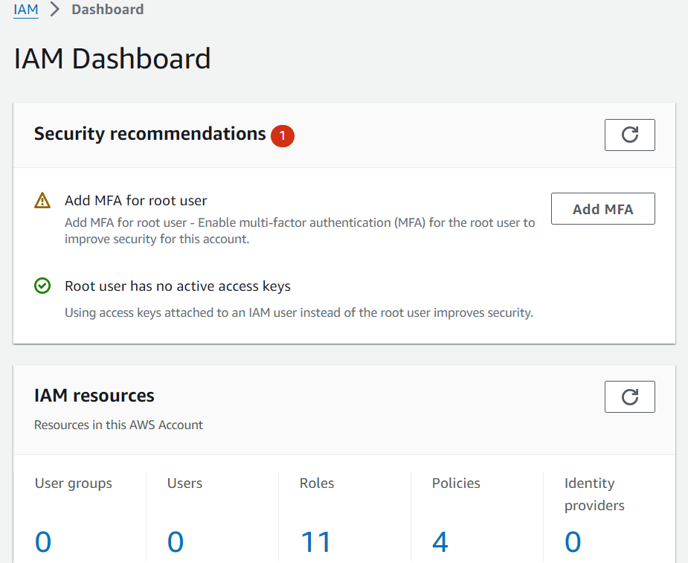

* Open roles in IAM
* Create Roles

# **Select trusted entity**

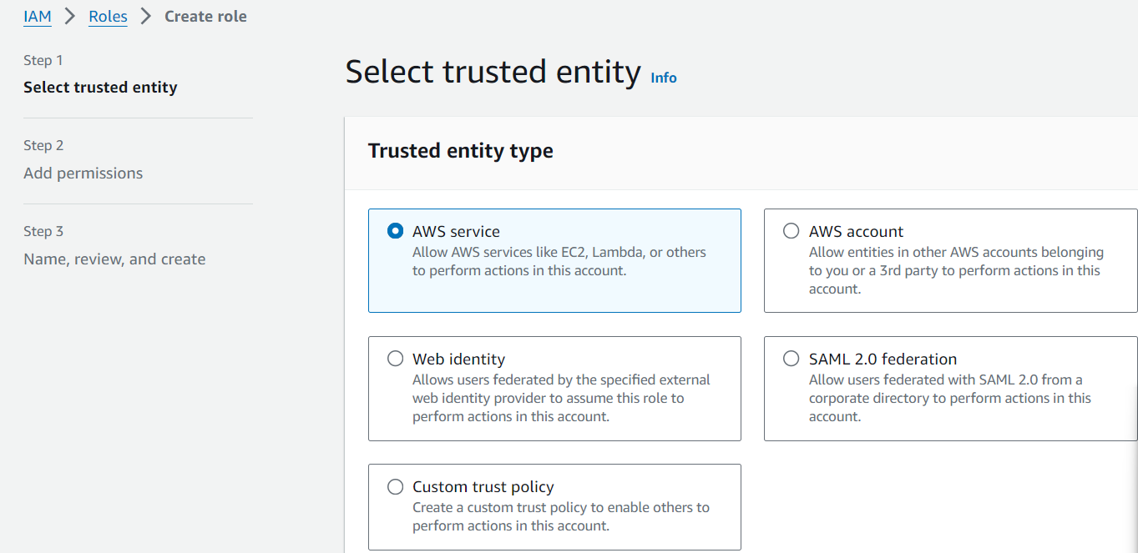

* Click on AWS service
* Use case select ec2

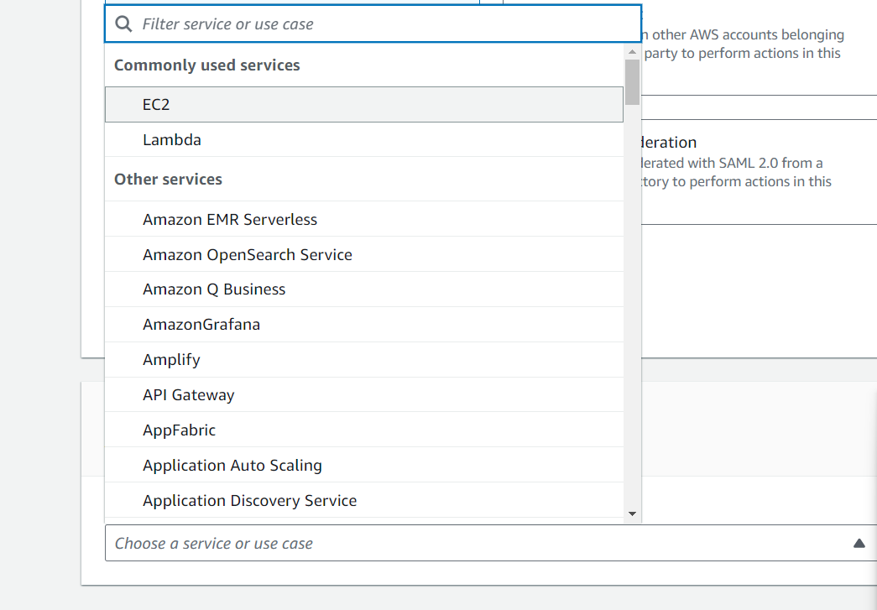

* Click on next
* **Permissions policies**
* **Click on amazon s3 full access & click in next**

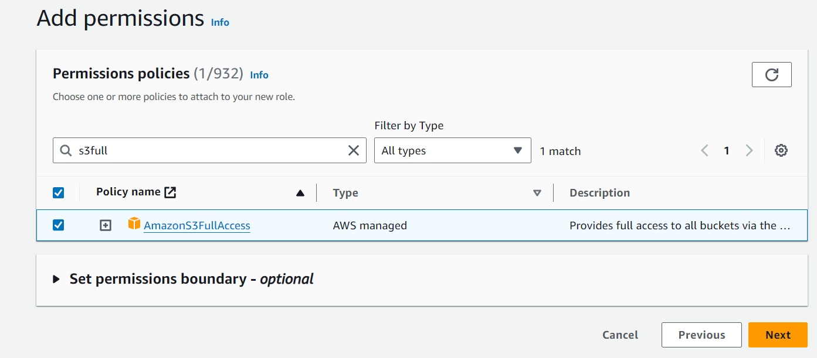

* Give the role name & create roles

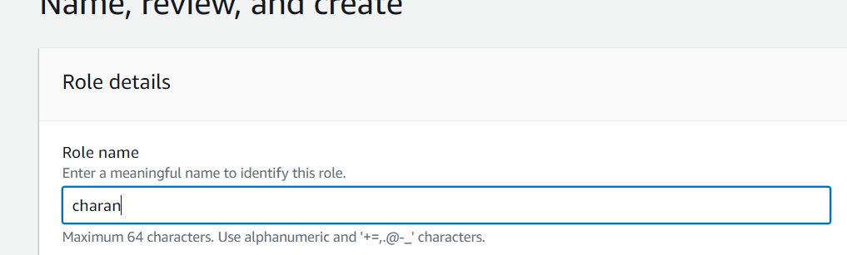

* Create a bucket and upload a file
* Next go to ec2 and create ec2 instance
* Click actions & and click on security

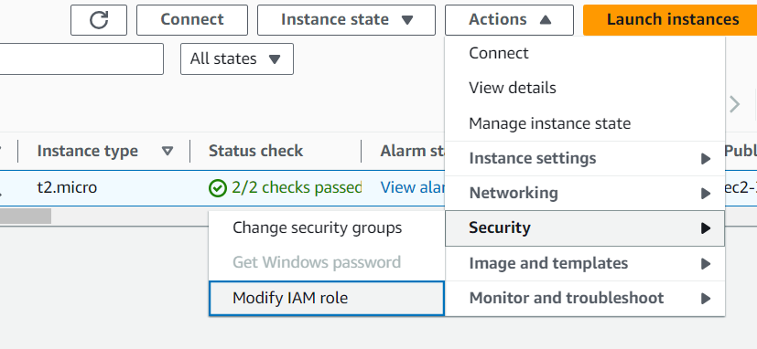

* Modify IAM role select the IAM which u created

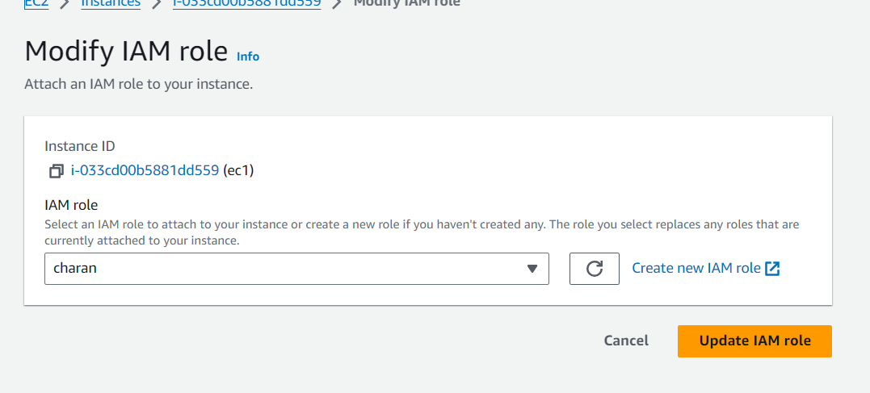

* Update IAM role and connect to ec2 instance server
* Click sudo -i, wget <https://s3.amazonaws.com/mountpoint-s3-release/latest/x86_64/mount-s3.rpm>
* Install mount & click on yes

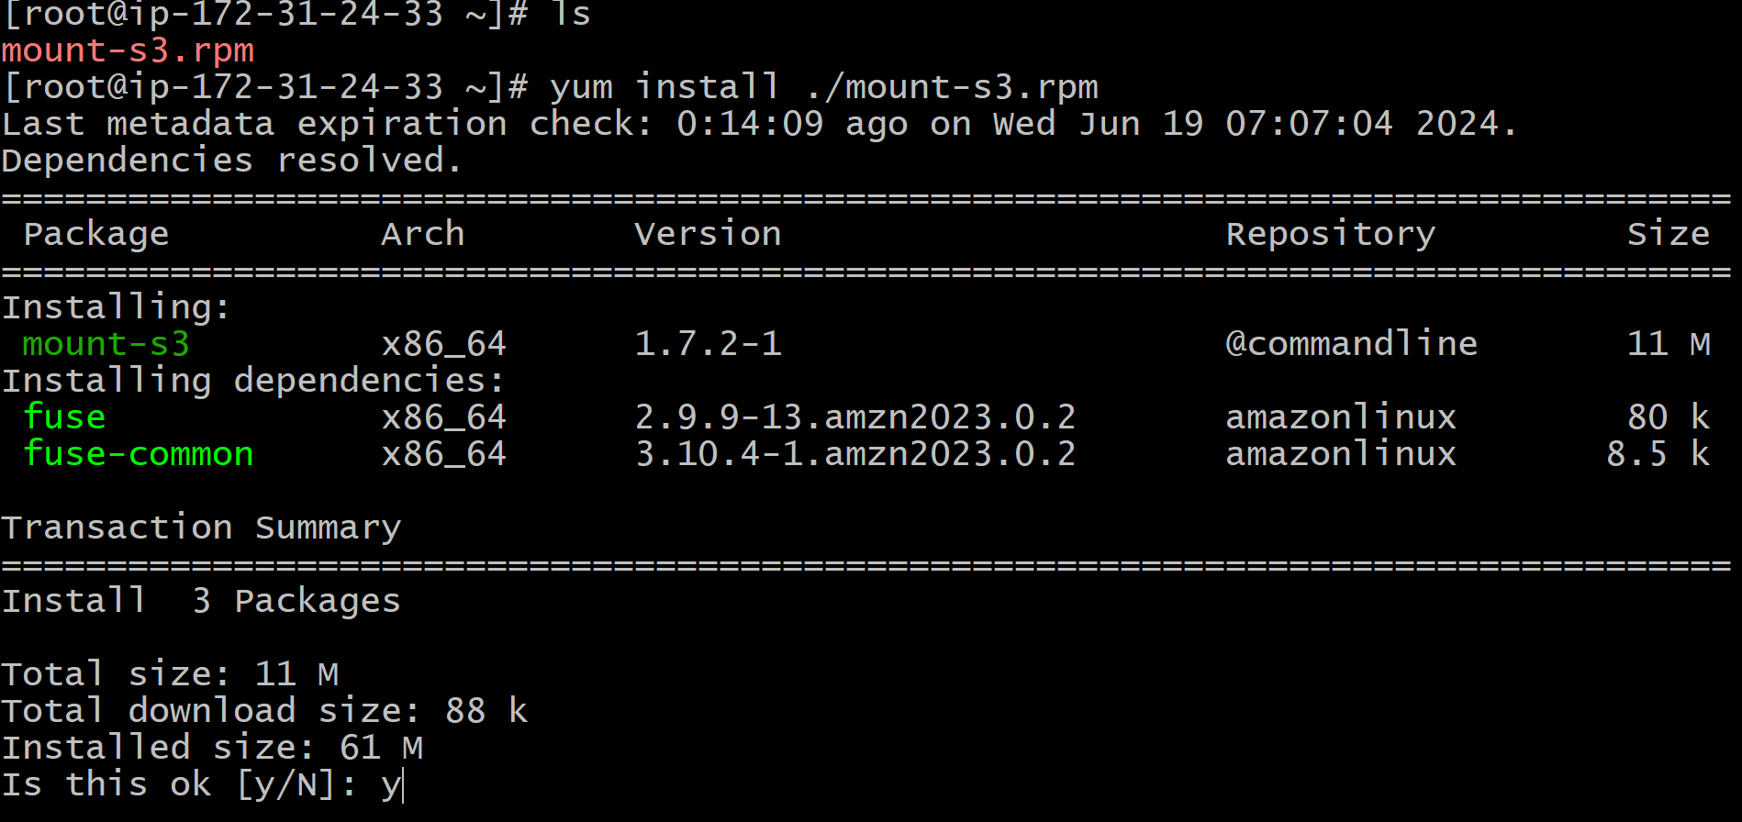

* Select your bucket & click entre

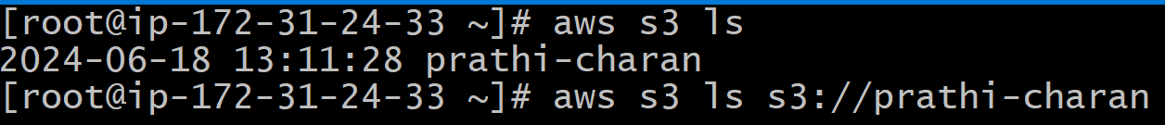

* Create a file s3mount and mount bucket with the file

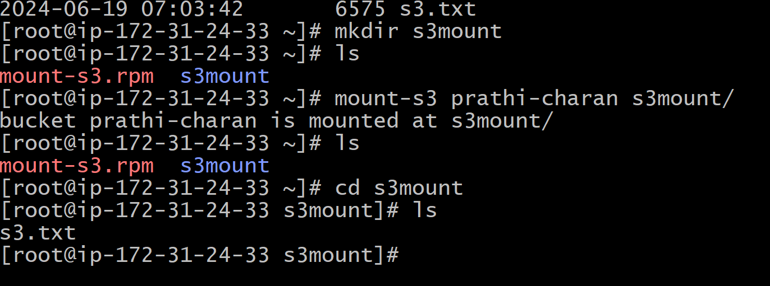

* Now we see the file in bucket from ec2 instance